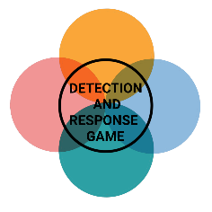**Name:**

|  |  |  |  |  |
| --- | --- | --- | --- | --- |
| **INITIAL ACCESS** | **PRIVILEGE ESCALATION** | **PERSISTENCE** | **LATERAL MOVEMENT, C2, EXFILTRATION** | **IMPACT** |
| PREVENTION | PREVENTION | PREVENTION | PREVENTION | PREVENTION |
| DETECTION | DETECTION | DETECTION | DETECTION | DETECTION |